**Lab 4. NOT gate**

1. **Parts：**

one 68KΩ Resistor (Blue, Grey, Orange) (**R1 in the diagram**)

one 1KΩ Resistor (Brown, Black, Red) (**R2 in the diagram**)

MPSA20 NPN Transistor

several solid wires

built-in logic probe

1. **NPN Transistor：**

MPSA20 NPN Transistor

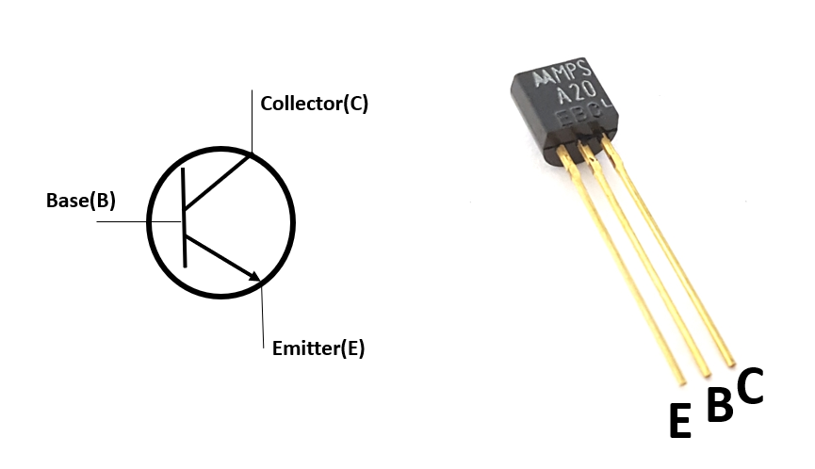

1. **NOT gate：**

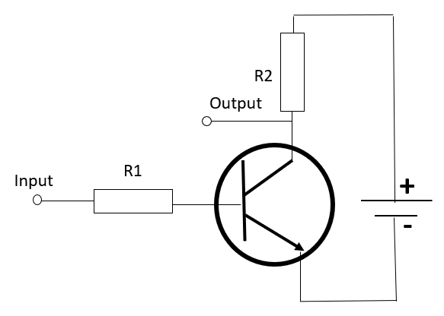

* 1. Connect the input to the positive bus strip as input is 1.

Connect the input to the negative bus strip as input is 0.

* 1. In order to probe the output, touch the tip of logic probe to the bare end of the output wire. See an example below:

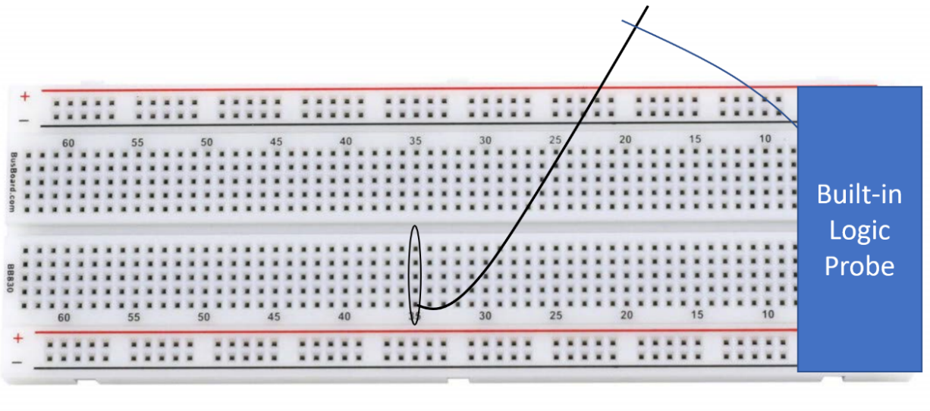

1. **Requirement:**

4.1 **First, before doing anything, check if your built-in logic probe is working well.**

4.2 Based on the schematic diagram of NOT gate, make the connection on the breadboard. **After checking the connection, connect the switch wire goes to the negative terminal of the battery.** Demonstrate the output corresponding to 1 and 0 inputs.

***If you finish it in class, no submission is needed. Otherwise, you need to take the pictures to prove your results and uploaded them to canvas. You need to take the picture of the results of Low and High inputs. Later, I’ll create a submission portal in canvas.***